Macintosh HD:Users:debrahsickler-voigt:Desktop:Routledge Logo copy.jpeg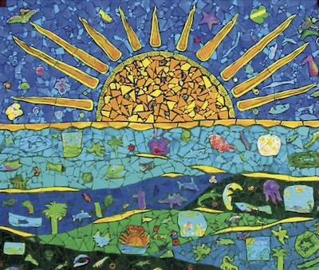

|  |  |  |  |  |
| --- | --- | --- | --- | --- |
| **200 Action Verbs for Writing Behavioral Objectives** | | | | |
| * adhere | * advocate | * align | * alter | * analyze |
| * animate | * appliqué | * apply | * appropriate | * arrange |
| * articulate | * assemble | * assess | * balance | * batik |
| * blend | * brainstorm | * calculate | * carve | * categorize |
| * change | * choose | * cite | * classify | * clean |
| * collaborate | * collage | * collect | * color | * combine |
| * communicate | * compare | * complete | * compose | * conclude |
| * connect | * construct | * contrast | * create | * critique |
| * curate | * cut | * debate | * decorate | * define |
| * demonstrate | * depict | * describe | * design | * determine |
| * develop | * diagram | * differentiate | * digitalize | * discuss |
| * display | * distort | * divide | * document | * dramatize |
| * draw | * edit | * elaborate | * embellish | * embroider |
| * emphasize | * engrave | * enlarge | * estimate | * evaluate |
| * exaggerate | * examine | * exhibit | * experiment | * explain |
| * film | * foreshorten | * form | * formulate | * frame |
| * generate | * glaze | * glue | * gradate | * graph |
| * grid | * highlight | * hypothesize | * identify | * illustrate |
| * imply | * improvise | * incorporate | * inspect | * install |
| * integrate | * interpret | * invent | * invert | * investigate |
| * join | * journal | * judge | * juxtapose | * knead |
| * layer | * locate | * manipulate | * mark | * mat |
| * measure | * mentor | * minimize | * mix | * model |
| * modify | * mold | * montage | * mosaic | * narrate |
| * observe | * organize | * outline | * overlap | * paint |
| * perform | * photograph | * plan | * plaster | * play |
| * portray | * practice | * prepare | * present | * prime |
| * print | * prioritize | * proof | * propose | * publish |
| * qualify | * quilt | * rank | * read | * recall |
| * refine | * reflect | * register | * reinforce | * relate |
| * render | * repeat | * reproduce | * repurpose | * research |
| * respond | * revise | * scale | * schedule | * score |
| * sculpt | * select | * self-assess | * self-reflect | * separate |
| * sew | * shade | * shape | * show | * sign |
| * size | * sketch | * slip | * smooth | * solve |
| * sort | * stamp | * stipple | * stitch | * stretch |
| * stylize | * substitute | * subtract | * summarize | * support |
| * synthesize | * teach | * thread | * tint | * touch |
| * trim | * unify | * utilize | * vary | * video |
| * visualize | * watch | * weave | * wedge | * write |

**Teaching and Learning in Art Education**

**Cultivating Students’ Potential from Pre-K Through High School**

Debrah C. Sickler-Voigt ©, Author

[www.arted.us](http://www.arted.us)

Routledge