  - Teaching and Learning in Art Education
  - Cultivating Students’ Potential from Pre-K Through High School
Lesson Plan Template
Title:
Name: | Grade Level: | Class Sessions:
Big Idea:
Essential Question(s):
Rationale: |  | Materials:  Instructional Resources:
Objectives:
Learning targets: |  | Elements of Art:  Principles of Art:  Other Vocabulary:
Procedures
Set:
Instructional Strategies:
Group Learning:
Independent Practice:
Accommodations:
Closure:
Assessment:
Informal Assessment:
Formative Assessment:
Formal-Summative Assessment:
Authentic Rubric Portfolio Test/Quiz Essay Peer/Group
Self-Assessment Interview Checklist Rating Scale Other - Worksheets
Standards

References

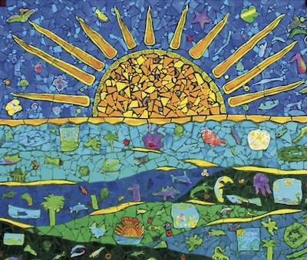
Debrah C. Sickler-Voigt ©, Author
www.arted.us

Routledge

