  - Teaching and Learning in Art Education
  - Cultivating Students’ Potential from Pre-K Through High School
Model Unit Plan
Name: Great Teacher
UNIt Title: Where We Come From: An Examination of Our Local Community
Grade Level: Multiple Grade Levels | Class Sessions: Two-Weeks: Full School Days
Essential Question(s):
- What is community?
- What makes my community unique?
- What is my role within the community?
- Why is it important to know more about the people, places, and things in my community?
Unit Rationale:
Community defines a sense of place and feelings of connection. In a community, we communicate with others and share our experiences. The introduction of community-based art education in the curriculum serves as a means to promote good citizenship, make meaningful contributions, develop a positive sense of community, mold values, and identify our personal role within the community. Working together with members of our community, we can problem-solve, learn from past traditions, and shape the future (T. Anderson & Milbrandt, 2005; Congdon, Blandy, & Bolin, 2001). Students will investigate the big idea community by studying local and internationally acclaimed artists. They will participate in art production activities, class discussions, and research as they work under the supervision of art and classroom teachers to meet each lesson’s objectives.
Title and Sequence of Lessons:
- Marionettes and the Story of Our Community
- Our Community: A Collaborative Story Quilt Mural
- Performing Community: A Marionette Production
References:
Anderson, T. & Milbrandt, M. (2005). Art for life. Boston: McGraw Hill.
Congdon, K. G., Blandy, D. & Bolin, P. E. (2001). Introduction. In K. G. Congdon, D. Blandy, & P. E. Bolin (Eds.), Histories of community-based art education (pp. 1-5). Reston, VA: National Art Education Association.
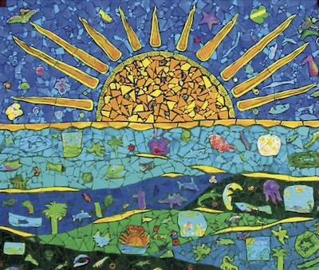
Debrah C. Sickler-Voigt ©, Author
www.arted.us

Routledge

