  - Teaching and Learning in Art Education
  - Cultivating Students’ Potential from Pre-K Through High School
Debrah C. Sickler-Voigt ©, Author
www.arted.us

Routledge
Model Teaching and Learning in Art Education Lesson Plan
TITLE: Marionettes and the Story of Our Community
NAME: Authentic Teacher | GRADE LEVEL: Multiple Grade Levels | Class Sessions: 5 – 1 hour classes
BIG IDEA: Our Local Community
ESSENTIAL QUESTION: What is the nature of our community?
RATIONALE: Dating back to prehistoric times, societies called upon puppetry to present social issues, teach life skills, and entertain audiences (Blumenthal, 2005; Currell, 2004). Using the essential question: “What is the nature of our community?,” this lesson calls upon students to explore the big idea our local community through content presented in a local museum’s exhibition on community, class discussions, and social justice. Students will discuss fairness and equity within the community, research the meaning of community, and apply contextual information to create marionettes.  Puppetry serves as an excellent medium to investigate the theme of community because of its appeal as an art form in encouraging children to discuss issues and reenact situations and events. By examining the work of local quilt makers and community artist Vannoy Streeter, as well as historical marionette artists and contemporary artist Faith Ringgold, students will learn the many ways in which artists have depicted storytelling and community in their art. Like the artists and societies before them, students will design marionettes for the purpose of presenting a story about community and sharing their sense of humor with others. |  | Materials:  string, fabric, ribbon, masking tape, buttons, fabric, glue, found objects, drawing paper, and pencils  INSTRUCTIONAL RESOURCES:  Artists’ Lessons to Thrive! 2.1. on Vannoy Streeter  - Faith Ringgold’s book Tar Beach  - Images of historical marionettes from around the world and the book Pablo Cano: Full Circle  - Teacher digital presentation on the community and the lesson’s artists  - Original teacher art criticism and aesthetic worksheets on community and the lesson’s artists
OBJECTIVES: (A) Given a class discussion on the significance of local community, the class will orally brainstorm ideas and make a list of at least ten unique things that represent life within their community. (B) The student will work in a small group to create an original marionette using found objects that has a moving head, arms, and legs and demonstrates a strong sense of unity, balance, and craftspersonship. (C) Given examples of Streeter’s sculptures, community and Ringgold’s quilts, historical marionettes, and artworks that depict the theme of community from the local museum, the student will answer all six aesthetic questions and all ten art criticism questions presented on the class handouts. The students will write their answers in complete sentences and present their answers orally to the class. (D) The students will utilize his/her marionette to perform a one- or two-minute show that focuses on the big idea local community.
  - Teaching and Learning in Art Education
  - Cultivating Students’ Potential from Pre-K Through High School
Debrah C. Sickler-Voigt ©, Author
www.arted.us

Routledge
Learning Targets:  - I can participate in a class discussion on the local community.  - I can work with my classmates to brainstorm a list of at least ten unique things about life in our community.  - As an artist, I can create a marionette.  - I can create a marionette with found objects that has a moving head, arms, and legs.  - I can design a marionette that demonstrates unity, balance, and craftspersonship.  - I can answer aesthetic and art criticism questions that focus on the big idea local community through art.  - I can answer ten art criticism questions on Streeter’s sculptures and historical marionettes.  - I can answer six aesthetic questions on community quilts and Ringgold’s story quilts.  - I can write my answers in complete sentences.  - I can summarize my answers orally to the class.  - I can present a marionette show.  I can use my group’s marionettes and set design to produce a one to two-minute show that focuses on the big idea local community. | Elements of Art:  form, texture  Principles of Art:  unity, balance  Other Vocabulary:  community, immigrant, marionette, puppet, social justice
PROCEDURES
SET: The teacher will present the big idea our local community, state the lesson’s essential questions, and present a digital presentation showing artworks by Vannoy Streeter, community quilters, Faith Ringgold, and marionette artists, as well as artworks on display at a local museum that tells the story of immigrants living in the region.
INSTRUCTIONAL STRATEGIES: (A) The teacher will collect found objects to create the marionettes and ask students to do the same. The teacher will: (B) identify the lesson’s objectives, vocabulary words, and assessment criteria and write key information on the board. (C) probe the students to identify the meaning of local community in their own lives. (D) demonstrate how to write a script and form a marionette using found objects. The teacher will explain safety procedures. (E) explain the procedures for completing the aesthetic and art criticism activities. (F) demonstrate how to decorate and string the marionettes. (G) monitor the class throughout the learning process and facilitate the class closure activities.
GROUP LEARNING: The students will: (A) repeat the lesson’s objectives and acknowledge that they understand them. (B) discuss the meaning of local community, identify the characteristics that make their community unique, and review vocabulary words. (C) participate in the class art criticism and aesthetic discussions and summarize their findings. (D) watch and participate in the teacher led demonstrations on how to write a script and form a marionette while following safety procedures. (E) work in small groups to write a script for their marionette show about our local community. (F) participate in a teacher led demonstration on how to decorate and string marionettes. (G) discuss the meaning of social justice and the role of fairness and equity within a community. (H) make final revisions to their marionettes and scripts upon receiving the class’s feedback.
  - Teaching and Learning in Art Education
  - Cultivating Students’ Potential from Pre-K Through High School
Debrah C. Sickler-Voigt ©, Author
www.arted.us

Routledge
INDEPENDENT PRACTICE:
The student will:
(A) complete the aesthetic and art criticism questions in written form. (B) create an individual marionette. (C) string the marionette.

ACCOMMODATIONS:
The teacher will:
(A) break down academic vocabulary and the steps necessary for students to participate in class art production, aesthetic, and art criticism tasks. (B) provide a hands-on demonstration to show students how to create a script and marionette. (C) post information on the board and provide additional instructional resources, such as handouts. (D) meet with students individually to review key information and check for understanding.

(E) If advanced learners progress through the marionette project more rapidly than their peers while meeting the project’s objectives, they can design additional props or other resources for their performance.

CLOSURE:
Students will:
(A) be responsible for cleaning their workspaces and storing their marionettes at the end of each class session. (B) orally review the big idea our local community, community centered artworks by Vannoy Streeter and the lesson’s other artists, and how creating art as well as writing, talking, and reflecting on the community, the artists, and their work provided them with enduring understandings about the local community.
(C) Upon completing the assignment, the class will perform their marionette shows and self-assess their performance orally as a class after its presentation.

Assessment:
Informal Assessment: The teacher will monitor the class as they participate in all activities to ensure that they are on-task.
Formative Assessment: Students and the teacher will review the learning targets and the rubric during the learning process to check for student understanding.
Formal-Summative Assessment: The students’ completed marionettes are worth 200 points using the criteria listed on a rubric. Each completed class worksheet is worth 50 points.
Authentic Rubric Portfolio Test/Quiz Essay Peer/Group
Self-Assessment Interview Checklist Rating Scale Other - Worksheets
  - Teaching and Learning in Art Education
  - Cultivating Students’ Potential from Pre-K Through High School
Debrah C. Sickler-Voigt ©, Author
www.arted.us

Routledge
Standards
National Visual Arts Performance Standards (SEADAE, 2014):
- VA:Cr2.3.5—Identify, describe, and visually document places and/or objects of personal significance.
- VA:Pr6.1.5—Cite evidence about how an exhibition in a museum or other venue presents ideas and provides information about a specific concept or topic.
- VA:Re7.2.5—Identify and analyze cultural associations suggested by visual imagery.
- VA:Cn11.1.5—Apply formal and conceptual vocabularies of art and design to view surroundings in new ways through art-making.
References
- Blumenthal, E. (2005). Puppetry: A world history. New York, NY: Harry N. Abrams.
- Clearwater, B. (2005). Pablo Cano: Full circle. In D. Fields (Ed.), North Miami, FL: Museum of Contemporary Art.
- Currell, D. (2004). Making and manipulating marionettes. Marlborough, Wiltshire: The Crowood Press.
- Moses, K. (1999). Outsider art of the south. Atglen, PA: Schiffer.
- Ringgold, F. (1991). Tar beach. New York, NY: Crown.
- State Education Agency Directors of Arts Education. (2014). National Core Arts Standards. Dover, DE: State Education Agency Directors of Arts Education.
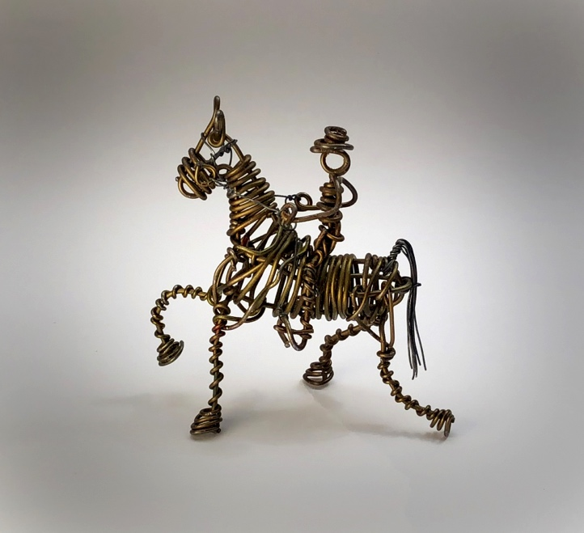
Vannoy Streeter, Tennessee Walking Horse. Jonathan Griffith, photo.

